

**Quick Links**

HOW TO SUBMIT AN IT SUPPORT REQUEST IT SUPPORT REQUESTS FAQS SHARED DRIVE ACCESS

3CX APP FOR ANDROID 3CX APP FOR IPHONE

FIRST TIME LOGGING IN OUTLOOK FOR IPHONE

OUTLOOK FOR ANDROID AUTHENTICATOR APP OPTIONS

**If you have any questions refer to the section below on how to contact the Help Desk.**

# IT Department

## New User Getting Started Guide - 20240819

### Accounts and Passwords

**Microsoft 365 Username:**

**Temporary Password*:**

**Microsoft 365 Email Address:**

**Phone Extension:**

**External Direct Dial Number:**

**Temporary Voicemail Password:**

* Password Complexity Requirements: **User must change password after first login**.  The password must meet the following complexity requirements:

Passwords must be between 8 and 256 characters and use a combination of at least three of the following: uppercase letters, lowercase letters, numbers, and symbols.

### Logging in for the first time and setting up microsoft authenticator

Open your computer and power it on if it is not already. You should see a screen similar to the picture below. Click “Other User” in the lower left corner:

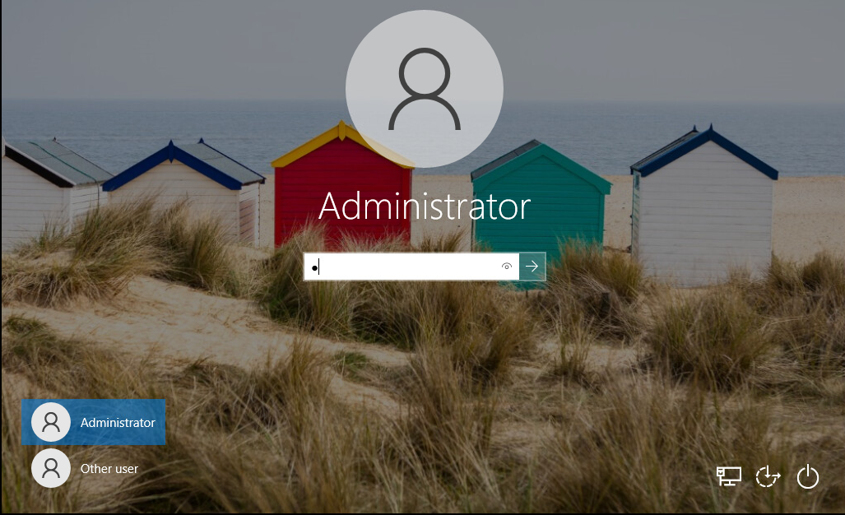

Input your email address password in the boxes:

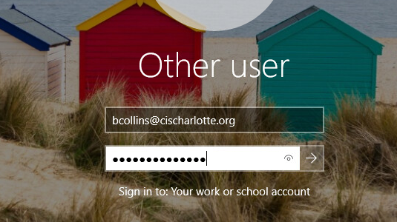

The system will begin loading your profile on the computer. This will take several minutes to complete. DO NOT SHUT OFF YOUR COMPUTER.

Next, you will see Windows Hello screen. Click OK

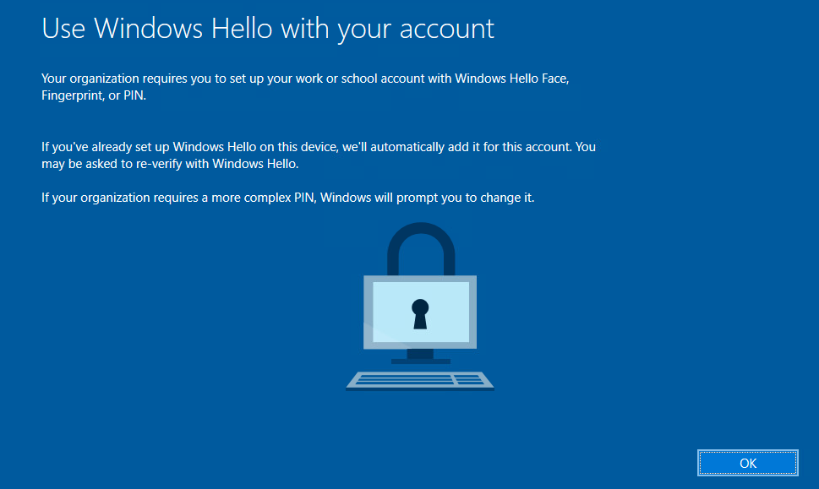

You will be prompted for your password. Enter it and click Sign In:

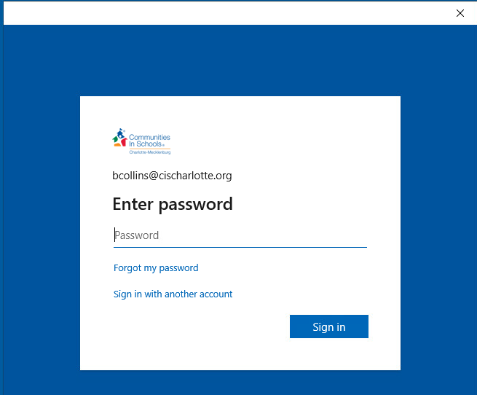

Click Next

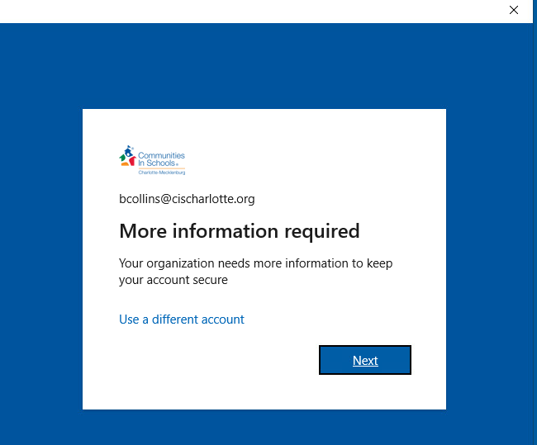

This is where you will setup your Microsoft Authenticator App on your **PHONE**. Open your phone and go the app store or google play store and download the Microsoft Authenticator Application. Once it installed on the phone click NEXT on the computer:

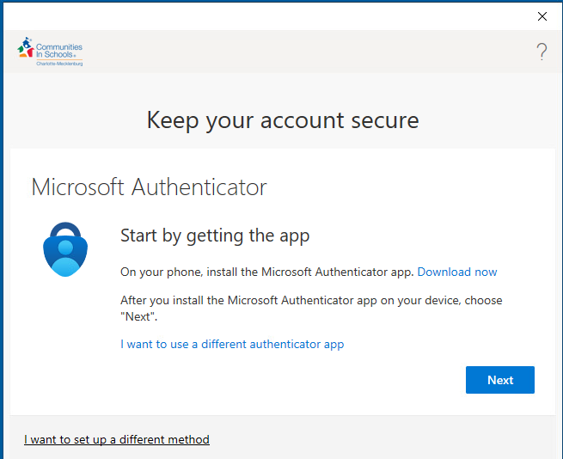

App Stores on Phones:

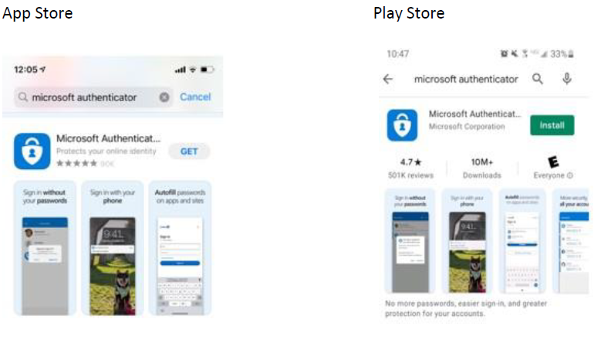

If you prompted for notifications on your phone after opening the Microsoft Authenticator App, CLICK ALLOW! Then click Add Account and select WORK OR SCHOOL. Then you will click next on the computer: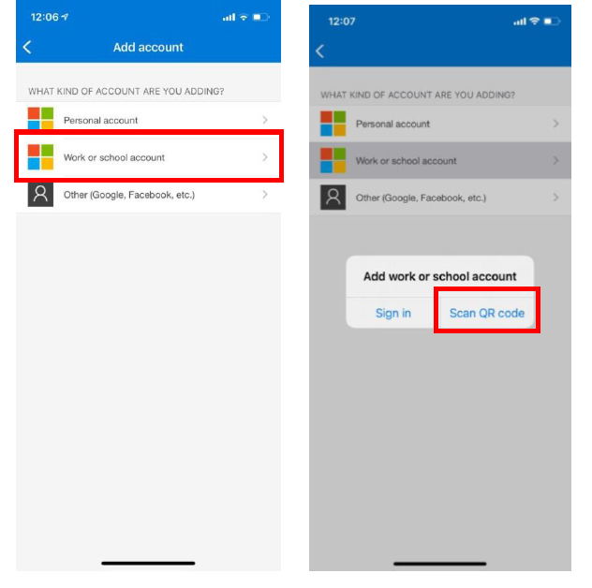

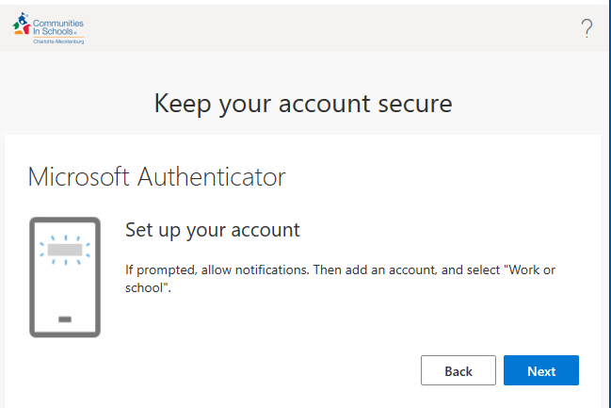

On the computer you will see the below screen. Leave it there. With the authenticator app, after clicked Work or School Account a pop-up will appear with an option for “SCAN QR Code” Select it. Point your phone at the QR code on the computer. This will add your account to the authenticator. Click Next on the QR Code Screen on your computer:

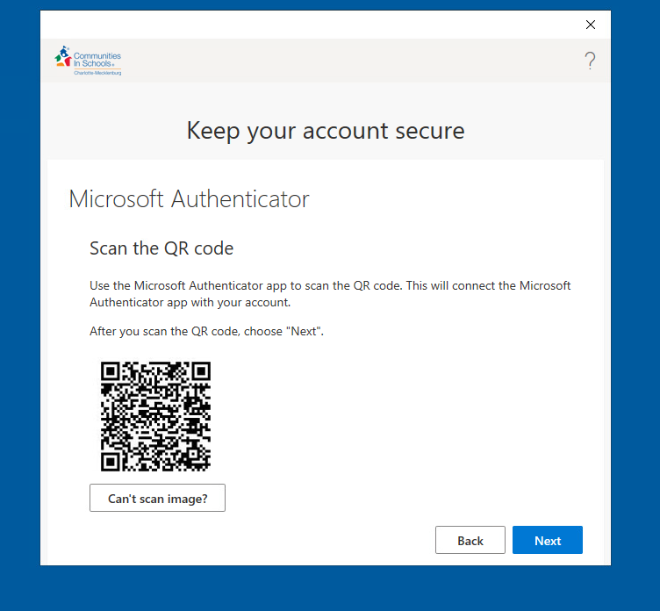

Do not try to use this QR Code on this form. It won’t work

The below screen should appear and you should get a notification on your phone, input the number you see on the computer into your phone and click yes on your phone.

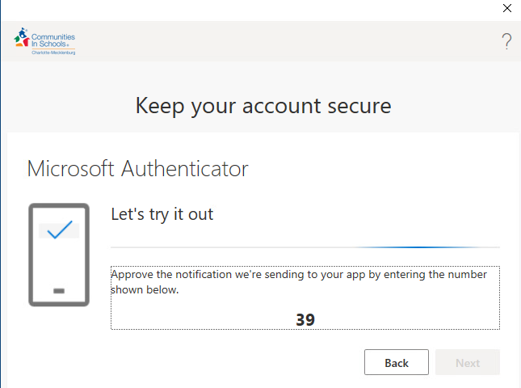

You should then see the below screen saying Notification Approved. Click Next:

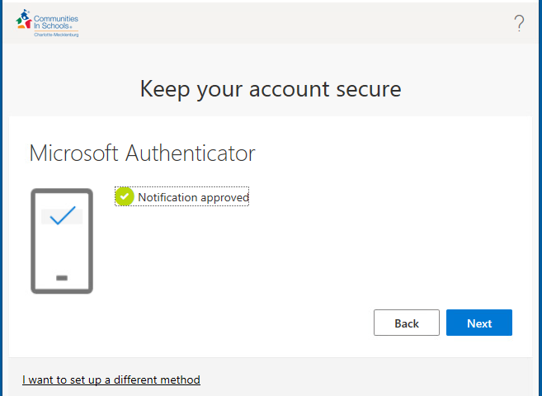

Click Done at this screen.

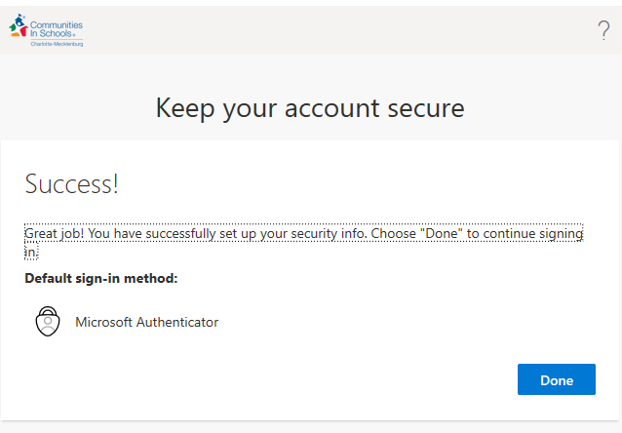

You should this screen now, however you may get a prompt to log back in first. If you do get the prompt put in your password and click sign-in and this screen will appear. In the first block – put your current password that IT gave you. Then the next two blocks create your own password. Make a note of the password so you don’t forget it. Click Sign In.

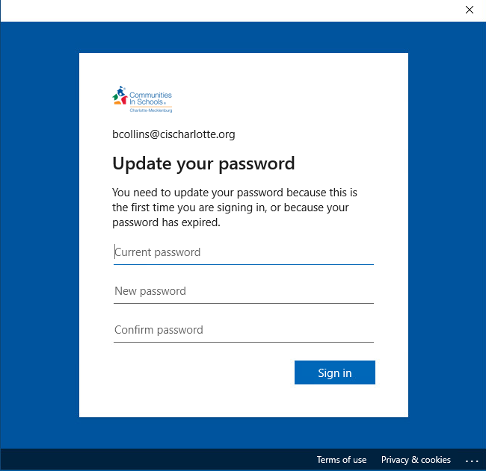

Next you will set up a Pin number you will use to login to the computer. Refer to the below for the requirements, or click the blue link that’s says PIN Requirements. Input your new PIN number twice and click OK.

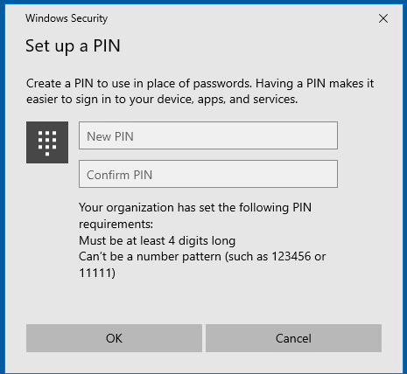

This window appear and you done setting up your profile and logging in for the first time. Click OK and desktop will appear.

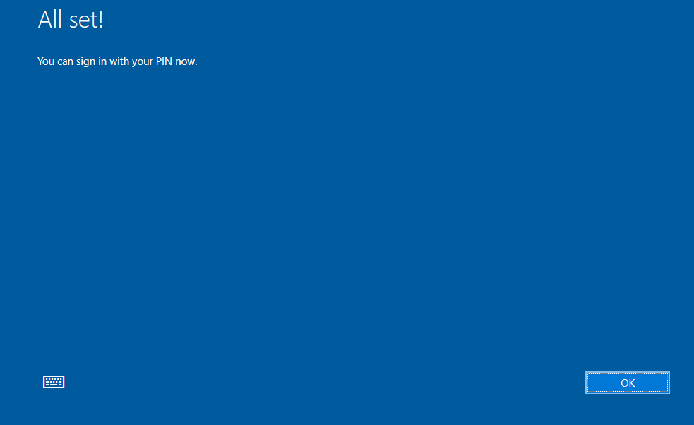

**One drive**

Sign-in to One Drive. Click Start > Scroll down to One Drive  and click it.

Input your email address in the block below and click sign in:

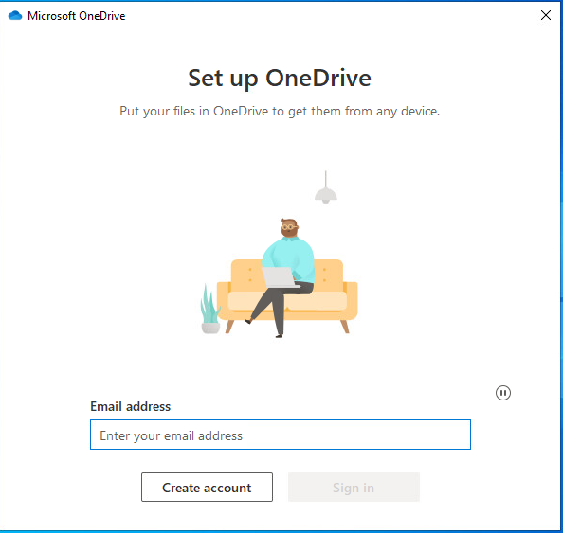

Input your password

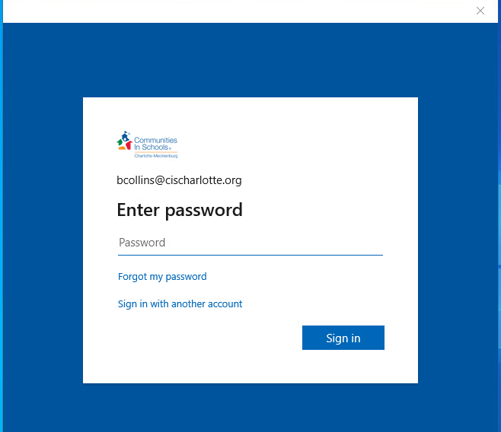

It will begin signing you in and come the screen below click next:

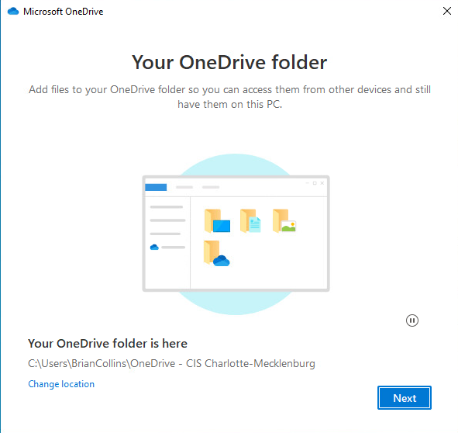

Click Start Backup

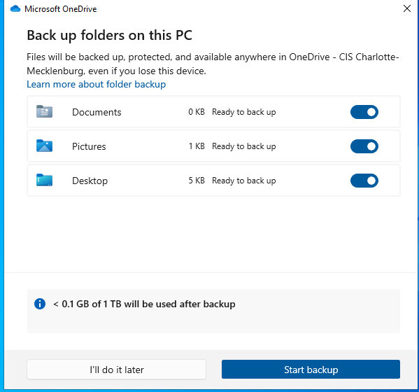

Click Next

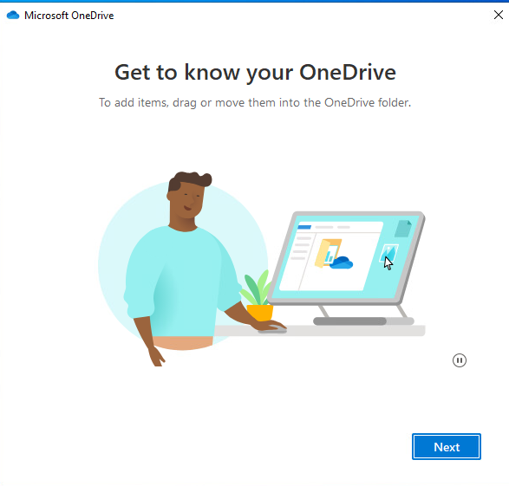

Click Next

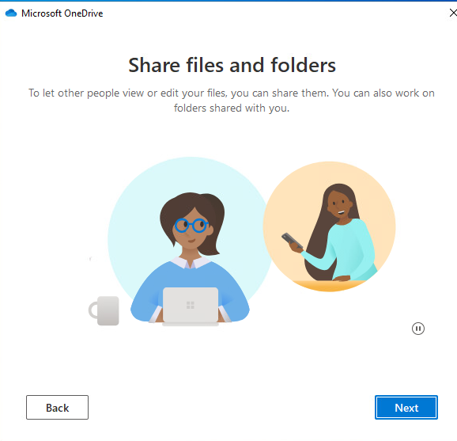

Click Next

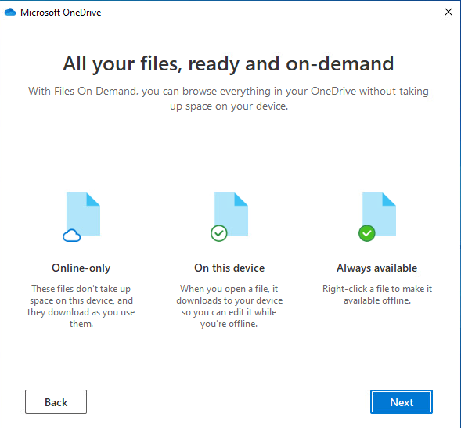

Click Later

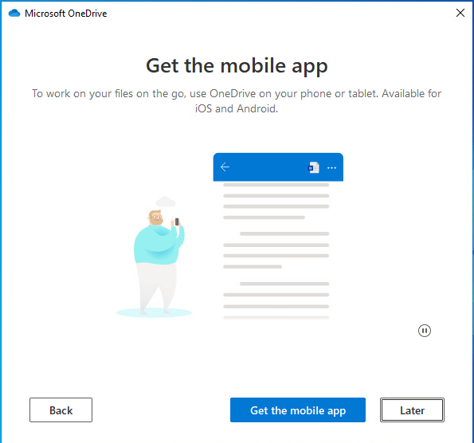

Click Open my OneDrive folder:

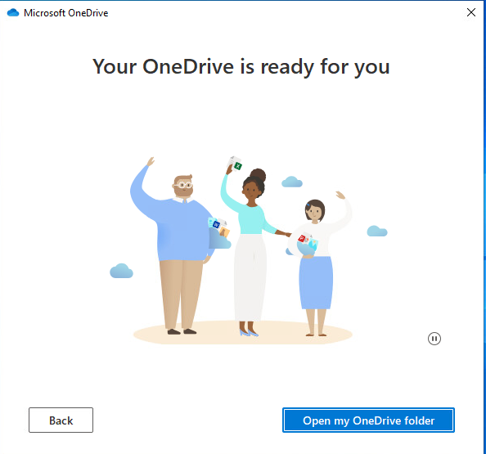

You One Drive will open:

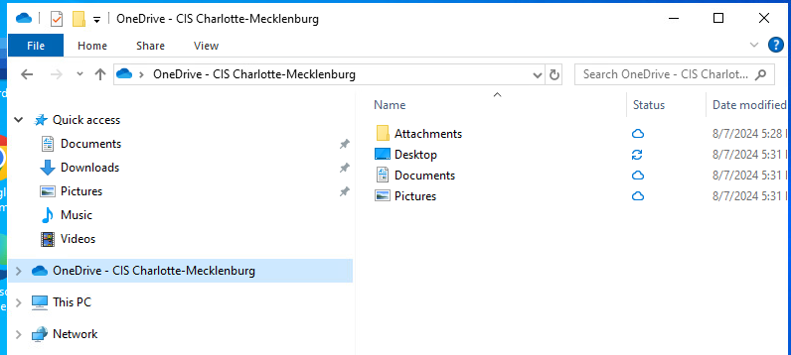

# Getting to your SHARED DRIVES

through file explorer

Click the Manilla Folder in taskbar to bring up the File Explorer window:

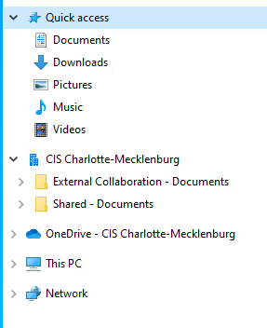

Note the Shared Drive for your agency will appear with what looks like a little building. If it is not there, open a web browser and navigate to [www.office.com](http://www.office.com) and sign in.

Click the button that looks like 9 dots in the top left corner and select SharePoint

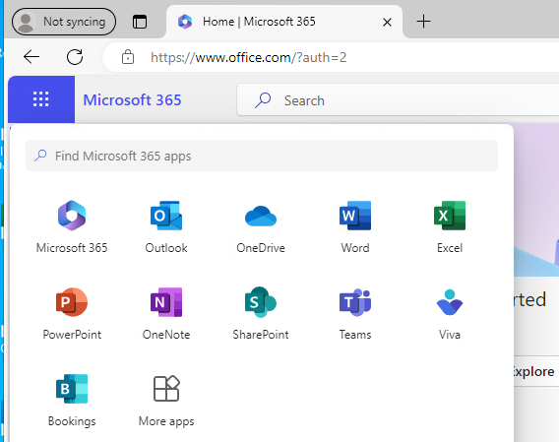

A new page will open up. In the search bar you will type Shared, or Media, or Public, or External Collaboration. These are the four primary drives within your agency that you will need access to: Click Search and then click Sites and you should something similar to below:

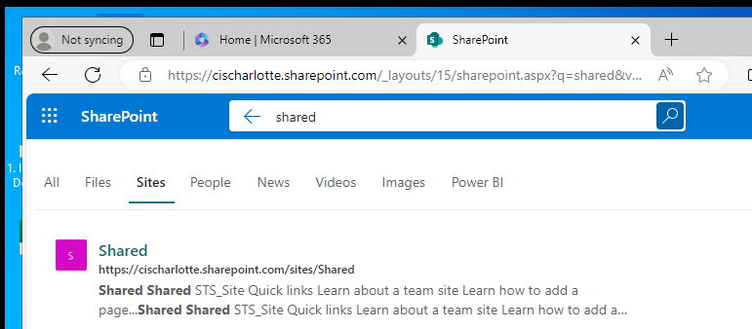

Click the site that you searched for and then Click on Documents:

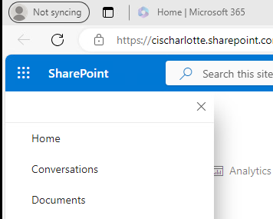

Click the Sync button:

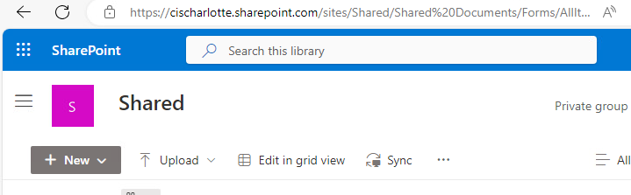

Click Open and Close and close the Browser.

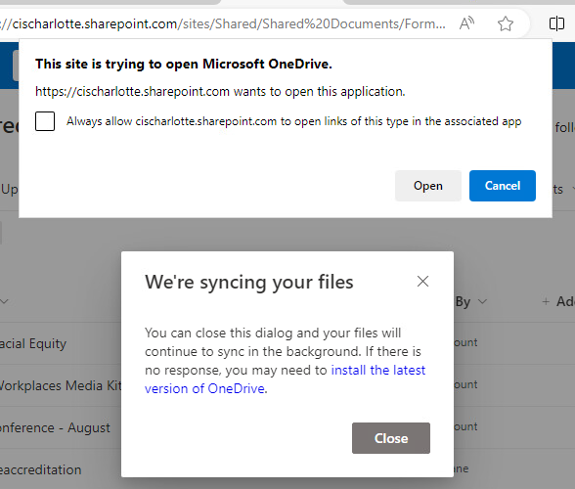

Close your web browser and reopen file explorer and you should see your drives.

# 3cX app for android

### Setting up your Extension

1. If you haven’t already, install the app from the Google Play Store.
2. Agree to the license agreement.
3. Allow 3CX to access the camera so you can provision your extension via QR code.
4. Scan the QR from your web client, desktop app or PWA.
5. Grant all the necessary permissions in the Permissions screen and you are all set.

QR Code example:



## Placing a Call with the 3CX Android App

Making a call with the Android app is quick and easy. In **“Contacts”** search by name, number or email address, click the phone icon next to the contact and hey presto! You are now using your office phone system from your smartphone.

1. Once you’re in a call, you can seamlessly perform a number of actions, including:
2. **“Transfer”** will give you the option to **“Blind”** without the need for you to speak to the receiver, or **“Attended”** will transfer the call after you first speak to the receiver to see if they accept the call and press **“Join”**.
3. **“Conference”** allows you to create an ad hoc conference call, adding more participants to join the conversation.
4. **“Rec”** allows you to record your conversation.
5. **“Video”** adds video to your call for face-to-face communication.

# 3cx app for iphone

## Setting up your Extension

1. If you haven’t already, install the app from the Google Play Store.

2. Agree to the license agreement.

3. Allow 3CX to access the camera so you can provision your extension via QR code.

4. Scan the QR from your web client, desktop app or PWA.

5. Grant all the necessary permissions in the Permissions screen and you are all set.

## Physical yealink phone

1. You have to log in to your phone before you can use it. Dial * 77 * ext # * (You need all 3 stars).
2. Press Call and the operator will come on the line.
3. Enter your 4 digit pin and press the pound sign. Ex. 1234#
4. Hang up and after 30 seconds you should see your name scrolling across the top of the phone screen.
5. Ready to make phone calls.

## Placing a Call with the 3CX iphone App

Making a call with the Android app is quick and easy. In **“Contacts”** search by name, number or email address, click the phone icon next to the contact and hey presto! You are now using your office phone system from your smartphone.

1. Once you’re in a call, you can seamlessly perform a number of actions, including:
2. **“Transfer”** will give you the option to **“Blind”** without the need for you to speak to the receiver, or **“Attended”** will transfer the call after you first speak to the receiver to see if they accept the call and press **“Join”**.
3. **“Conference”** allows you to create an ad hoc conference call, adding more participants to join the conversation.
4. **“Rec”** allows you to record your conversation.
5. **“Video”** adds video to your call for face-to-face communication.

QR Code Example



## Setup voicemail on 3cx app or Desktop Phone

1. In the app, dial 9999

2. Enter your voicemail PIN followed by #

3. Dial 9 to go to options

4. Dial 8 to change your greeting message

# Authenticator App

### Adding app to a different phone

You can go to this website to login and setup an authenticator app on a different phone. This is useful if you are trying to setup email or some other application on a work phone and have to use authenticator.

Go to the following website and login with your email and password:

<https://aka.ms/mfasetup>

 Select Add Sign-In Method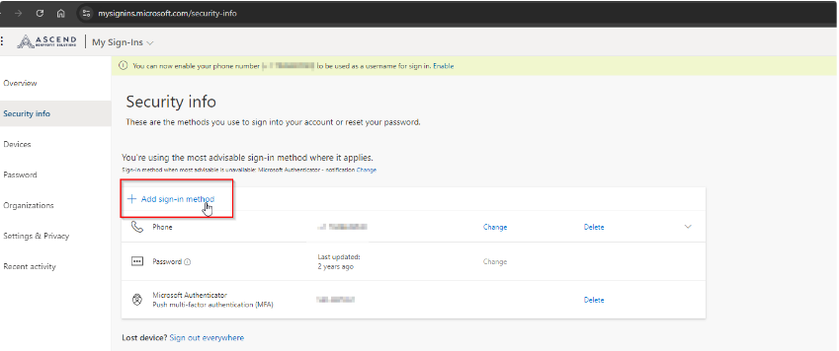

Select Authenticator App:

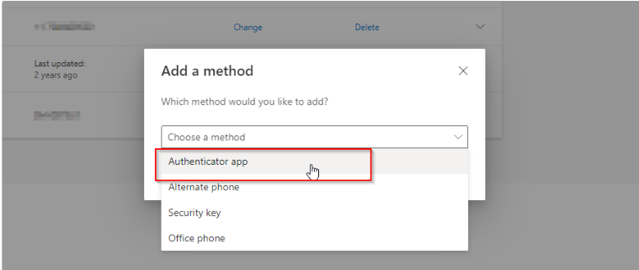

Follow the on-screen instruction at this point:

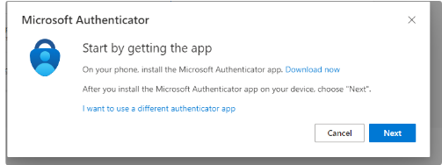

**If you do not have the original phone you had MFA setup on you can.**

-Attempt to login with other options(text or call) if you have them setup

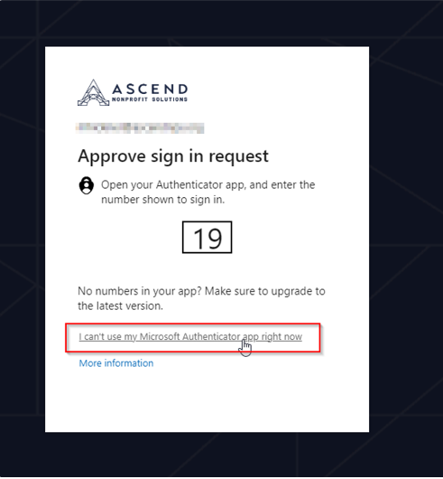

-plugin to our network in the office and then follow the first directions. <https://aka.ms/mfasetup>

-put in a ticket for us to clear your MFA so it will just ask you next time you login.

# outlook for iphone

### iphone outlook instructions **some screens may look different due software versions**

Go to the App Store Click Search Type MS Outlook and click search

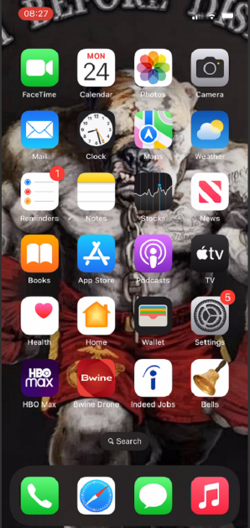 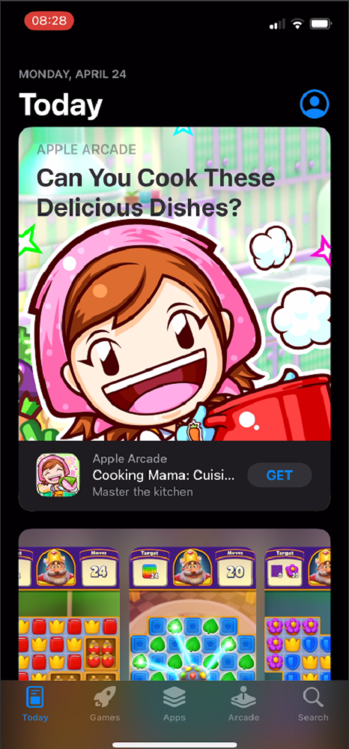 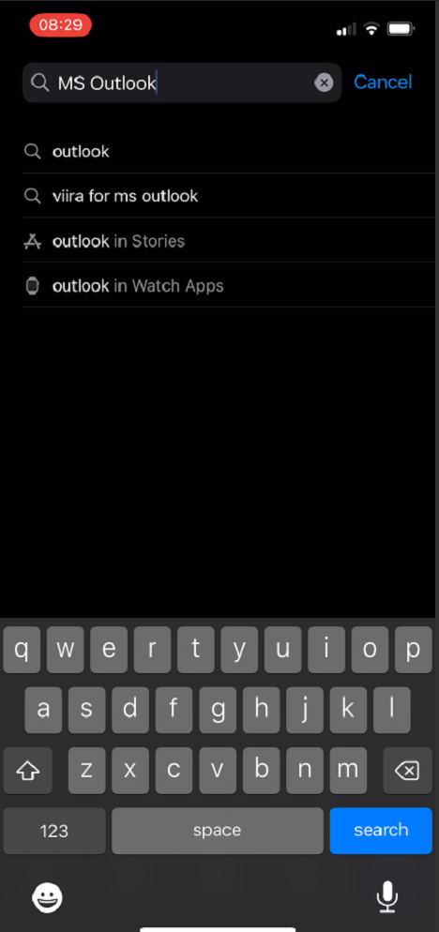

Click the Download icon Click Open Click Add Account

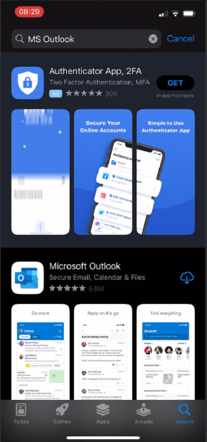 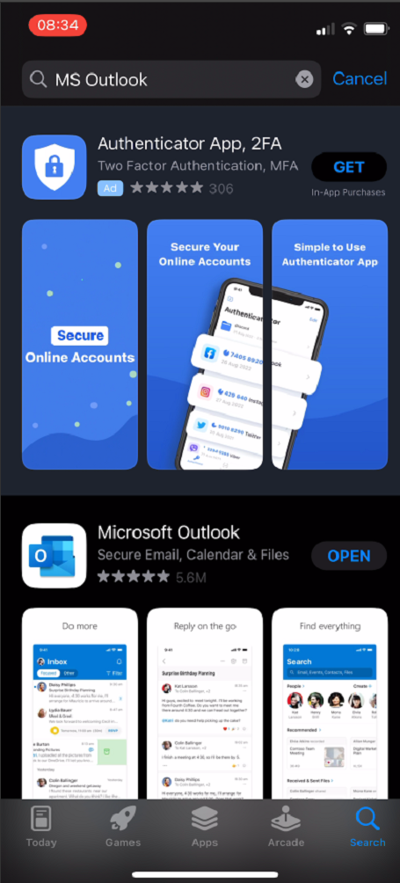 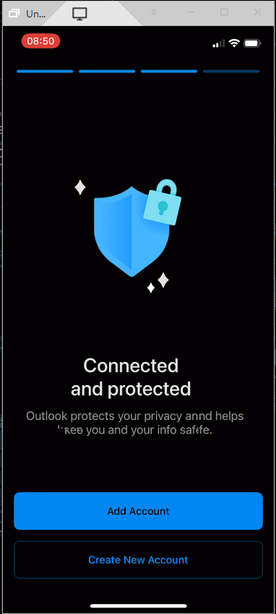

Click Your Email if it comes If you clicked skip type in your

up or Skip if it doesn’t. email and click add account

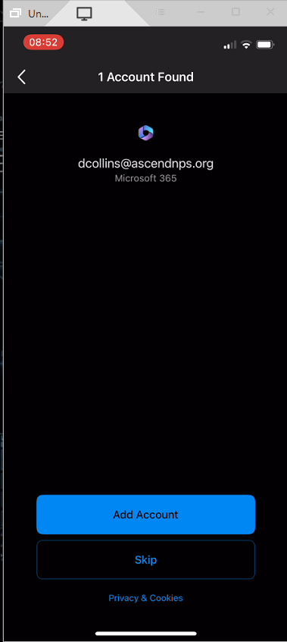 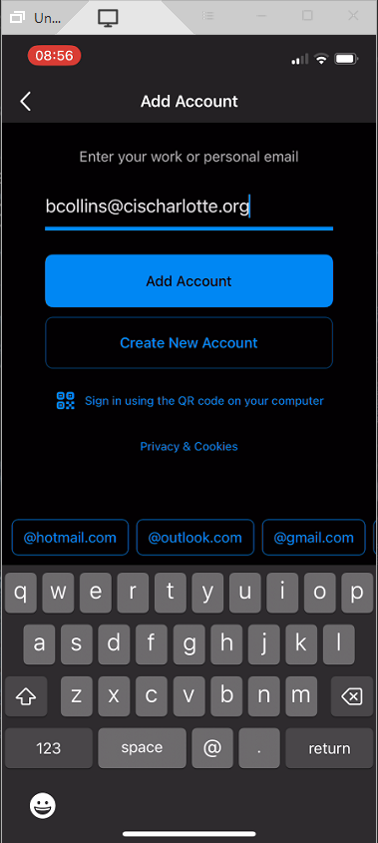

Click Open Authenticator Enter you password and click Sign In

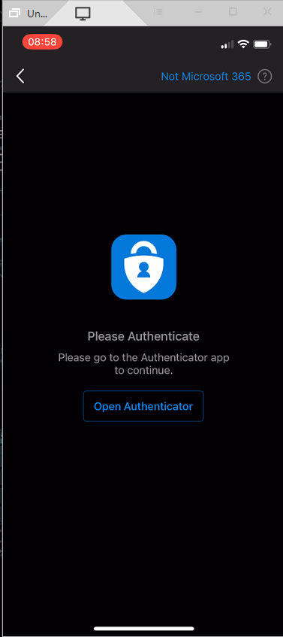 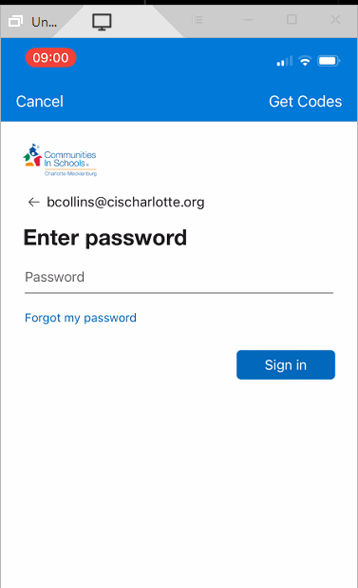

Enter the code you were given Click Maybe Later

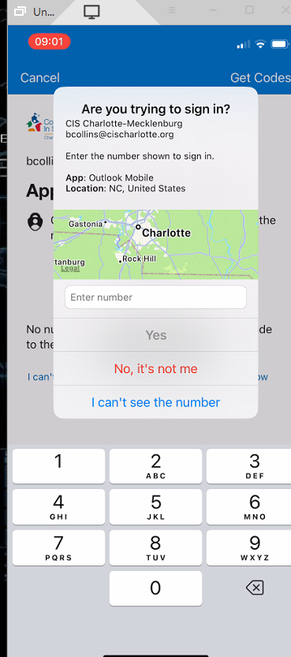 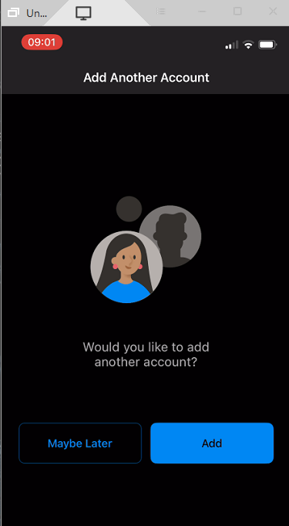

Optional: If you want Outlook contact to be saved to your phone do the following:

Click the blue button. Select the Gear

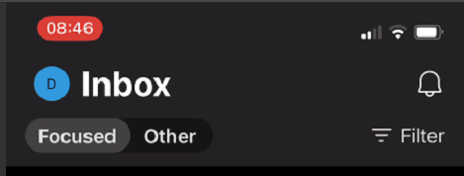 

Select Contacts Click the toggle button until changes color and you are done

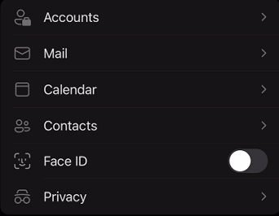 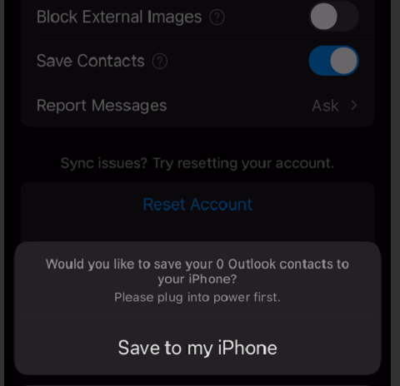

# outlook for android

### Android outlook instructions **some screens may look different due software versions**

1. Go to Google Play and download the MS Outlook Application.

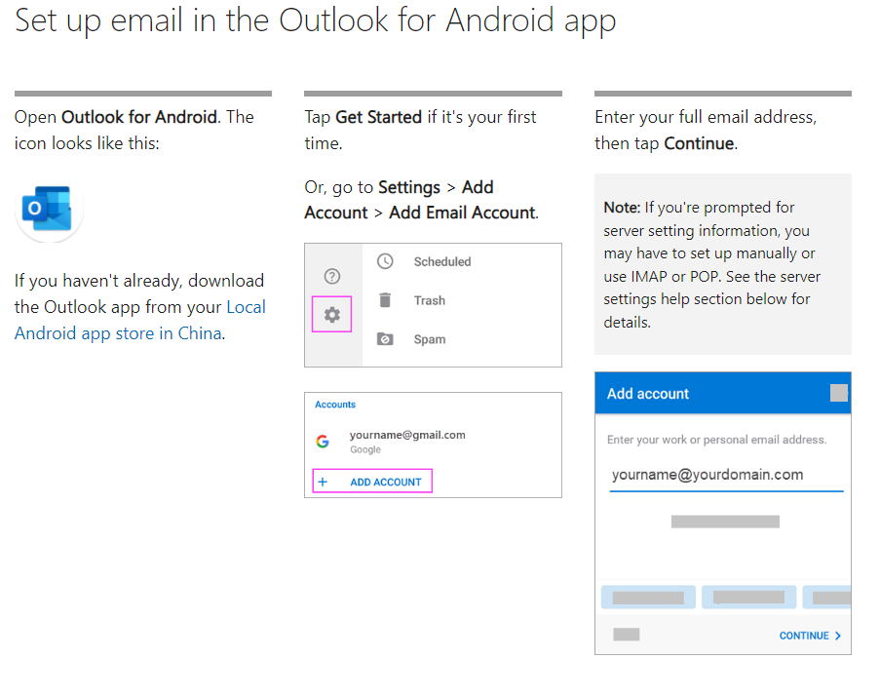

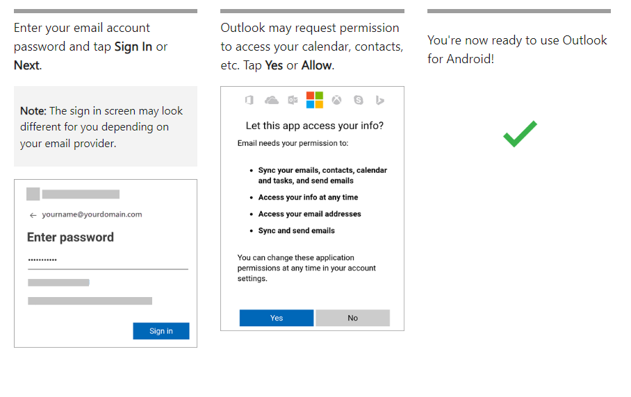

Note: Your screens may not look exactly the same due to software updates and different models of the phone.

# IT Support

The CFSC IT Department has an IT helpdesk to provide support for computer related issues. You should **submit all IT support requests** to the IT helpdesk using one of three methods outlined in the ***How to submit and IT support request*** section below. Once your support request is received, helpdesk technicians will contact you to service the request. All helpdesk technicians will have the ability to take remote control of your computer (with your permission) if needed to resolve an issue.

The CFSC IT Department provides a broad range of support for various technologies. Below are examples of technologies we support:

* Hardware and Operating System support for desktops and laptops (provided they are complaint with our standards).
* Email and Spam Filtering
* Phone and Voicemail
* Printing (limited support for desktop printers)
* Internet access (on-site only)
* Account Management (account unlock, password reset, account additions\removals, etc.)

**Personal Computers**: Please note: The ANPS IT Department does not provide support for personal\home computers, devices, or internet access outside our building or branch offices. Although personal devices may be used to access our network (i.e. checking work email, remotely accessing your work computer, etc.), it is the responsibility of the user to ensure their security and functionality.

**Support Hours**: IT Helpdesk support hours are from 7AM to 6 PM Monday through Friday, excluding holidays.  
**After Hours Support**: IT Helpdesk support after hours, including weekends, is only for Global and Systemic issues. Individual issues will be addressed on the next normal business day. If you feel you have a system wide emergency, please contact your supervisor. Supervisors will have an after-hours on-call phone number.

# How to submit an IT support request

**Email your issue to** [**helpdesk@ascendnps.org**](mailto:helpdesk@ascendnps.org)

* Include your name, agency (i.e. A Child’s Place, Care Ring, etc.), and contact information along with a description of the issue.
* It is always important to include your **cell phone number** and as much detail about your issue as possible (what triggers the issue; any troubleshooting steps you’ve already tried; if the issue occurs at any specific times, etc.).

**Call the CFSC IT Helpdesk at extension 9526 (Outside Line: 704-943-9526)**

* Use this option if you don’t have access to email

# IT Support Requests FAQs

1. **How do I contact the IT Helpdesk if my PC won’t turn on?**
   1. Call the IT Helpdesk at extension 9526 (outside line: 704-943-9526).
2. **How do I make sure someone will contact me back?**
   1. Although we make every effort to find and contact the person who submitted a request, sometimes it’s very hard for us to track you down if you don’t include your contact information.  For faster response times, please include your full contact information with every support request.  Your contact information should include your name, email address, and a **reliable call back number**.
3. **How soon can I expect a follow-up?**
   1. IT Helpdesk technicians will make every effort to respond to your request as soon as possible.  Response times will vary depending on the severity of the issue and workload.  In most cases, technicians are able to reach you within a few hours.  On busier days, it may take several hours.  **The promised response time is within 24 hours** of your support request.  If you haven’t heard back in 24 hours, please feel free to contact the IT Helpdesk again.